**DOKUMENTASI IMPLEMENTASI DI SERVER STAGING**

1. **Mechine Learning Tensorflow-clasificaton-image**

|  |  |  |  |
| --- | --- | --- | --- |
| **NO** | **TASK** | **KETERANGAN** | **STATUS** |
| 1 | Git Clone Server dari https://github.com/IntegriaNusaPrimera/tensorflow-clasificaton-image.git | Lokasi di Server : /home/dendie/ghc/tensorflow-clasificaton-image | **SUDAH** |
| 2 | Instalasi Enviroment Python (Python 3.6, Tensorflow,pip dan dependensi lainnya) |  | **SUDAH** |
| 4 | Instalasi menjalankan Program yang running di background meggunakan screen -m -d python3 app.py | screen -m -d python3 app.py | **SSUDA SUDAH UDUDA** |
| 3 | Run App Mechine Learning di Server | App berjalan di http://103.152.118.179:5000 | **SUDAH** |

**A.1 Screen shoot ML Classification image jalan di port http://103.152.118.179:5000/**

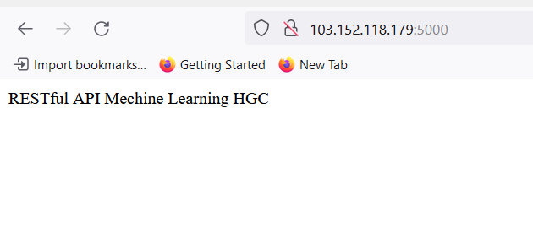

**A.2 Testing Postman**

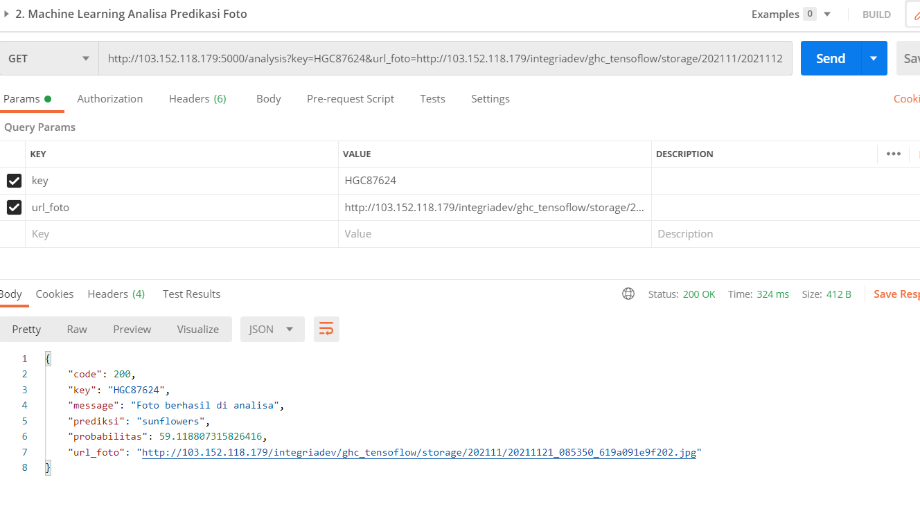

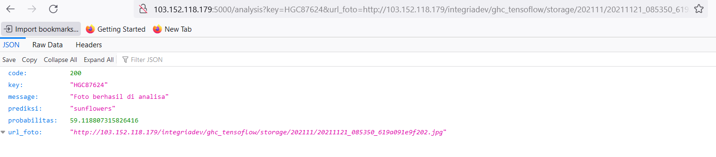

**A.3 Screen shoot ML Classification image jalan Python jalan di background**

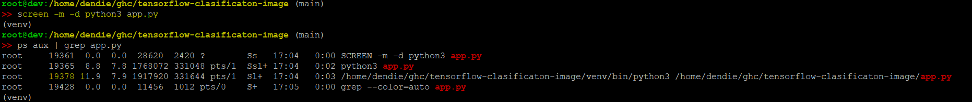

1. **Mechine Learning Tensorflow-contribute**

|  |  |  |  |
| --- | --- | --- | --- |
| **NO** | **TASK** | **KETERANGAN** | **STATUS** |
| 1 | Git Clone ke Server dari https://github.com/IntegriaNusaPrimera/tensorflow-contribute | Lokasi di Server : /home/dendie/ghc/tensorflow-contribute | **SUDAH** |
| 2 | Instalasi Enviroment Python Python (Python 3.6, Tensorflow,pip dan dependensi lainnya) |  | **SUDAH** |
| 3 | Instalasi menjalankan Program yang running di background meggunakan screen -m -d python3 app.py | screen -m -d python3 app.py | **SUDAH** |
| 4 | Run App Mechine Learning di Server | App berjalan di http://103.152.118.179:5001 | **SUDAH** |

**B.1 Screen Shoot Contribute Running di http://103.152.118.179:5001**

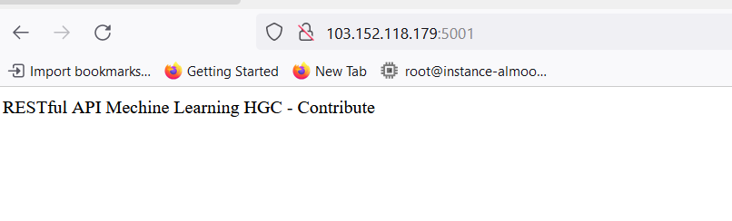

**B.2 Testing Postman**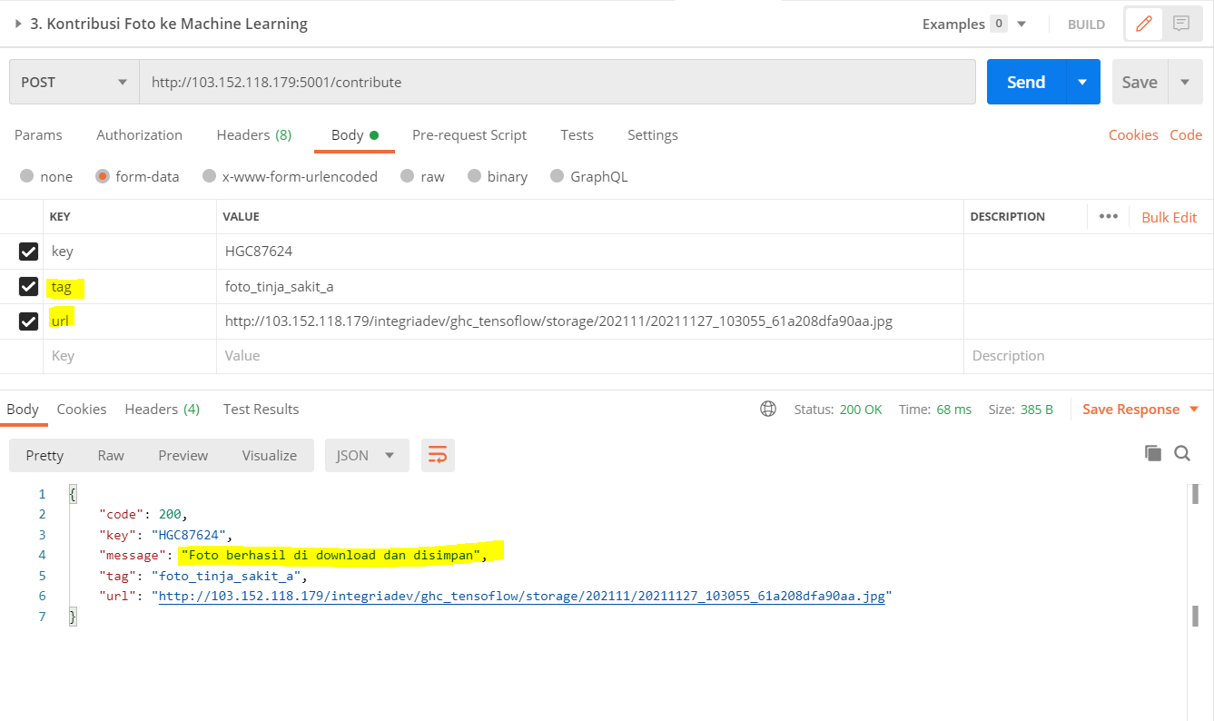

**B.3 Screen shoot Contribute image jalan Python jalan di background**

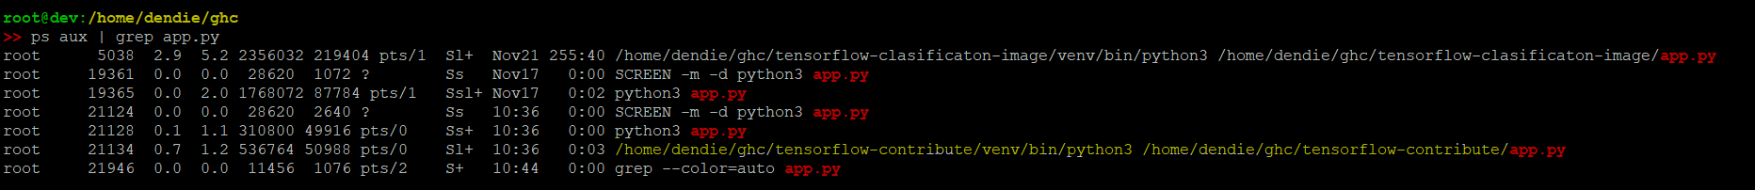

1. **Mechine Learning Tensorflow-upload-foto**

|  |  |  |  |
| --- | --- | --- | --- |
| **NO** | **TASK** | **KETERANGAN** | **STATUS** |
| 1 | Git Clone ke Server dari https://github.com/IntegriaNusaPrimera/tensorflow-upload-foto | Lokasi di Server  /var/www/html/integriadev/ghc_tensoflow | **SUDAH** |
| 2 | Instalasi PHP Lib Depdency (PHP GD) imagecreatetruecolor() | Update Repisitory Ubuntu  Install php7.3-GD | **SUDAH** |

**C.1 Screen shoot Upload Foto jalan di http://103.152.118.179/integriadev/ghc_tensoflow/**

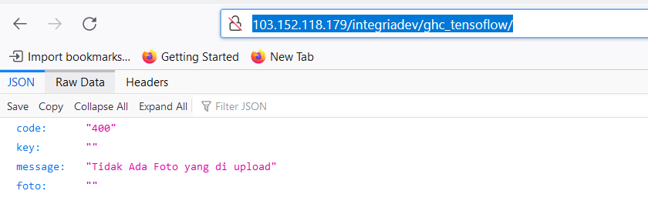

**C.2 Testing di Postman http://103.152.118.179/integriadev/ghc_tensoflow/**

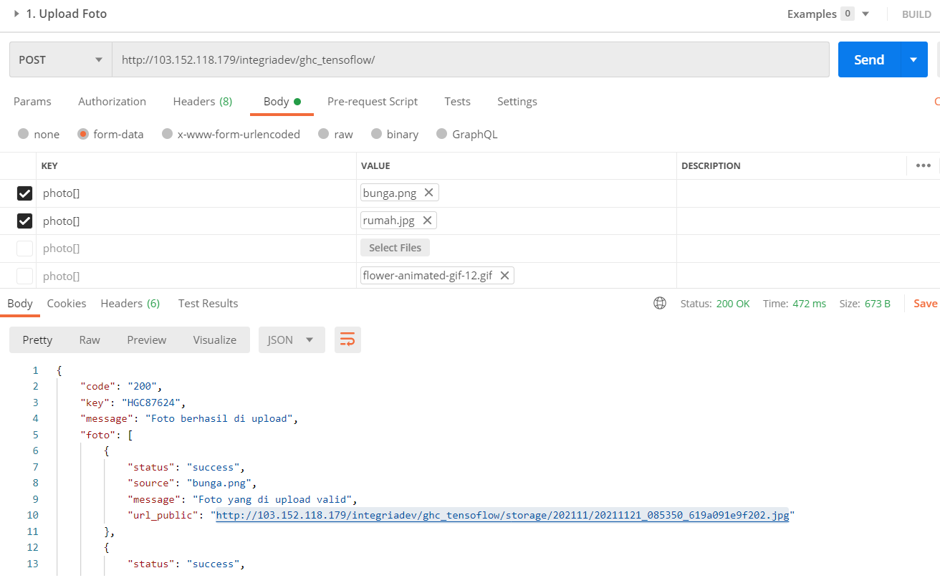

1. **Informasi Tambahan**

**E.1 Python 3.6 sudah di install untuk di ML Tensor Flow (Enviroment Variable)**

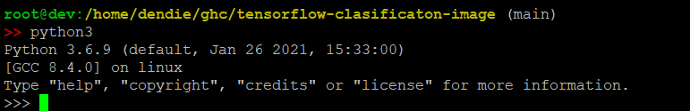

**E.2 Upgrade-GD di PHP 7.3 yang digunakan di Web Server**

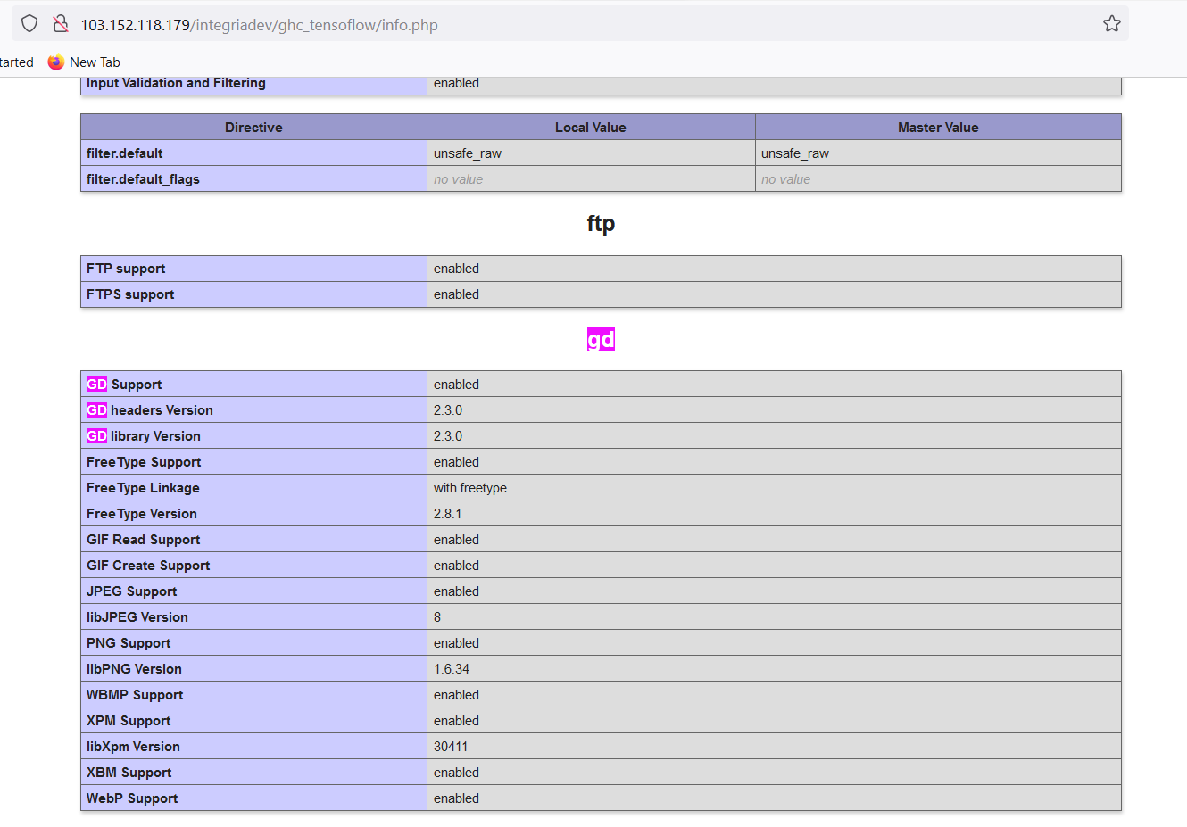

1. **Postmant Collection**

<https://github.com/IntegriaNusaPrimera/tensorflow-clasificaton-image/blob/main/documentation/Integria-tensoflow.postman_collection.json>

